EMBOCS, Nawalaparsi
Class: 7(seven)
Grid for First Terminal Examination-2081
Subject: Health, Physical and Creative Arts Time: 2hrs FM: 50
PM: 18
SN | Chapters | Very short questions | Short questions | Long questions | Total Marks
1 | Human Body | 3×1=3 | 3×2=6 | 1×4=4 | 13
2 | Community Health And Mental Health | 3×1=3 | 3×2=6 | 2×4=8 | 17
3 | Physical Training And Drill | 2×1=2 | 2×2=4 | 1×4=4 | 10
4 | Introduction To Arts, Drawing AndColour | 2×1=2 | 2×2=4 | 1×4=4 | 10
 | Total | 10×1=10 | 10×2=20 | 5×4=20 | 50

Model question for First Terminal Examination
Subject: Health, Physical and Creative Arts Time: 2hrs FM: 50
PM: 18
(Attempt all the following questions)
Group: A (Very short questions) 10×1=10
- Which blood cells fight against disease?
- How many members are there in a heart ?
- Which is the last track of digestive system ?
- Who are called new born ?
- Write one role of auxillary health worker of Nepal ?
- Write some herbal medicine found in Nepal ?
- Define drill ?
- Write one importance of physical exercise ?
- What is an art ?
- Write the name of cool colour.
Group: B (Short questions) 10×2=20
- Write the main function of Kidney.
- Write one differences between Artery & Veins ?
- Write the name of organs in digestive system ?
- Define community health?
- Write two short-term effects of using drugs.
- Write two improtions of the immunizations .
- How can we stay attention positions ?
- Difine disper command in drill .
- Draw some geometrical shape in drawing .
- Why pencil is popular tool ?
Group: C (Long questions) 5×4=20
- Draw a well-lebelled drigram of urinary system?
- Make a list of the services provided by the auxillary health worker in Nepal ?
- Explain about forward march and mark time .
- What are the basic rules of art ?

Class: 7(seven)
Grid for Second Terminal Examination-2081
Subject: Health, Physical and Creative Arts Time: 2hrs FM: 50
PM: 18
SN | Chapters | Very short questions | Short questions | Long questions | Total marks
1 | Human Body | 1×1=1 | 2×2=4 | 1×4=4 | 9
2 | Community Health And Mental Health | 2×1=2 | 1×2=2 | 2×4=8 | 12
3 | Nutrition And Food Security | 1×1=1 | 2×2=4 | 1×4=4 | 9
4 | Physical Training And Drill | 1×1=1 | 1×2=2 |  | 3
5 | Athletics and adventure activities | 2×1=2 | 1×2=2 |  | 4
6 | Introduction To Arts, Drawing AndColour | 1×1=1 | 2×2=4 | 1×4=4 | 9
7 | Printing,Clay Work, collage and construction | 2×1=2 | 1×2=2 |  | 4
 | Total | 10×1=10 | 10×2=20 | 5×4=20 | 50

Model question for Second Terminal Examination
Subject: Health, Physical and Creative Arts Time: 2hrs FM: 50
PM: 18
(Attempt all the following questions)
Group: A (Very short questions) 10×1=10
- Which blood vessel carry oxygenated blood from the heart to different part of the body?
- Write a function of health center .
- Mention an importance of mental health.
- Which vitamin strengthens our eyesight .
- Difine dismiss command in drill.
- Name any two sports played in water ?
- What is athletics ?
- Difine shape in drawing .
- Write one use of clay?
- Write the name of warm colours?
Group: B (Short questions)
- Difine urinary bladder .
- What are the types of blood vessels ?
- Name some sources of protion.
- Write two causes of using drugs .
- Write down main effects of using junk food.
- When is the eyes right command used?
- What are the skills of high-jump ?
- Mentions any three dimentions of art ?
- Write any two properties of of clay?
- Difine printmaking . 10×2=20
Group: C (Long questions) 5×4=20
- Describe blood –circulations peocess.
- Write the role of auxillary nurse midwitery (ANM).
- Write preventive measures of using drugs .
- What are the haemful effects of food-adulterations .
- Describe the types of colour.

Class: 7(seven)
Grid for Third Terminal Examination-2081
Subject: Health, Physical and Creative Arts Time: 2hrs FM: 50
PM: 18
SN | Chapters | Very short questions | Short questions | Long questions | Total marks
1 | Human Body | 1×1=1 |  | 1×4=4 | 5
2 | Community Health And Mental Health | 1×1=1 | 2×2=4 | 1×4=4 | 9
3 | Nutrition And Food Security | 1×1=1 | 2×2=4 |  | 5
4 | Disease, Safety Education And First Aid | 1×1=1 | 2×2=4 | 1×4=4 | 9
5 | Physical Training And Drill | 1×1=1 | 1×2=2 |  | 3
6 | Athletics and adventure activities | 1×1=1 | 1×2=2 |  | 3
7 | Games | 1×1=1 |  | 1×4=4 | 5
8 | Introduction To Arts, Drawing AndColour | 1×1=1 | 1×2=2 |  | 3
9 | Printing,Clay Work, collage and construction | 1×1=1 | 1×2=2 |  | 3
10 | Singing And Playing Instruments | 1×1=1 |  | 1×4=4 | 5
 | Total | 10×1=10 | 10×2=20 | 5×4=20 | 50

Model question for Third Terminal Examination
Subject: Health, Physical and Creative Arts Time: 2hrs FM: 50
PM: 18
(Attempt all the following questions)
Group: A (Very short questions) 10×1=10
- Write the one function of nose ?
- What is diseases ?
- What are drugs ?
- Name some example of junk-foods.
- How drill is done in a group.
- Write some examples of althletics activities.
- What are the basic skills of football ?
- Define pencil.
- How collage is done?
- How many counts or taal in Kaharawa Taal.
Group: B (Short questions) 10×2=20
- Define Mental -Health ?
- What are the long-term effects of drug ?
- Write two preventive-measures against food adultration ?
- What are the functions of catbohydrates ?
- Define first-aid.
- What are the symptoms of tonsilits.
- Why drum is used in drill ?
- Why art is called an universal language ?
- How can we play short-put .
- What is coiling in clay work.
Group: C (Long questions) 5×4=20
- Draw a well-lebeled diagram of human heart.
- Why Yoga therapy is beneficial for human-body.
- What are the first-aid for snake bite.
- How kho-kho game is played ?
- What is singing ? Write the importance of it .

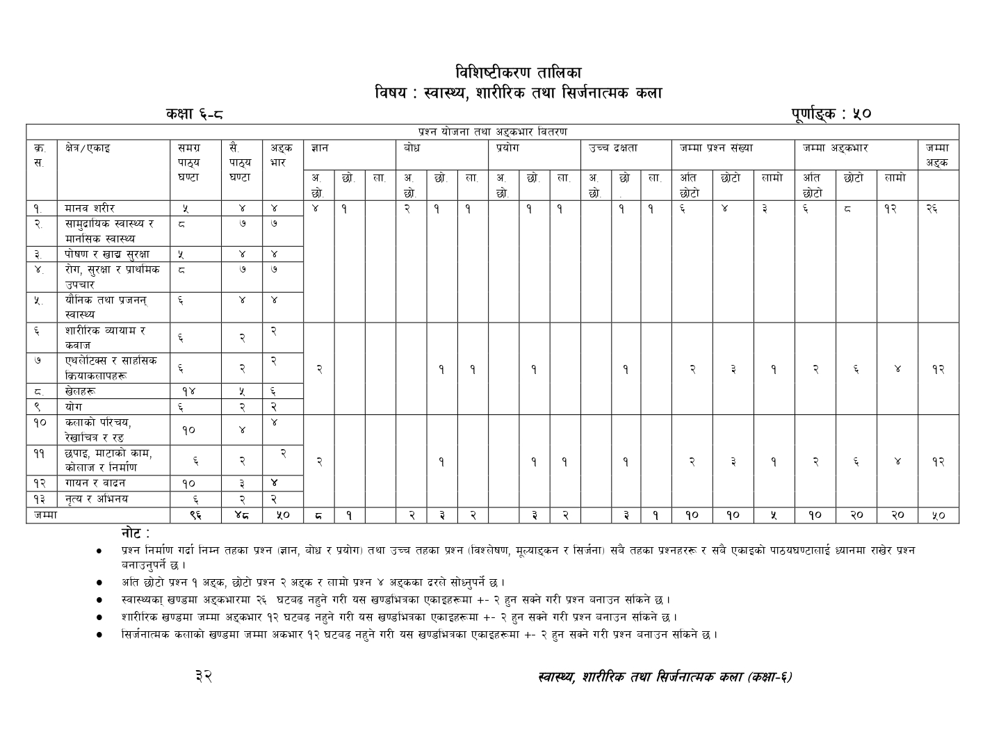

Class: 7(seven)
Grid for Final Terminal Examination-2081
Subject: Health, Physical and Creative Arts Time: 2hrs FM: 50
PM: 18
SN | Chapters |  | Very short questions | Short questions | Long questions | Total marks
1 | Human Body |  | 2×1=2 | 1x2=2 |  | 4
2 | Community Health And Mental Health |  | 1×1=1 | 1×2=2 | 1×4=4 | 7
3 | Nutrition And Food Security |  | 2×1=2 | 1×2=2 |  | 4
4 | Disease, Safety Education And First Aid |  | 1×1=1 | 1×2=2 | 1×4=4 | 7
5 | Sexual and reproductive Health |  |  |  | 1x4=4 | 4
6 | Physical exercise and drill |  |  | 1×2=2 |  | 2
7 | Athletics and adventure Activities |  |  | 1x2=2 |  | 2
8 | Games |  |  | 1×2=2 | 1x4=4 | 6
9 | Yoga |  |  | 1×2=2 |  | 2
10 | Introduction to Arts, Line art and colour |  |  |  | 1×4=4 | 4
11 | Printmaking, clay work, collage and construction |  | 2x1=2 |  |  | 2
12 |  | Singing and playing instrument | 2×1=2 | 1×2=2 |  | 4
13 |  | Dance and acting | 2×1=2 |  |  | 2
 |  | Total | 10×1=10 | 10×2=20 | 5×4=20 | 50

Question Construction Check List-1

S.N. | Unit | Marks | K | U | A | HA | Total Marks
! | dfgj z/L/ | $ | 1VS | 1VS  1S |  |  | 26
@ | ;fd'bflos :jf:Yo / dfgl;s :jf:Yo | & | 1VS  1S |  |  | L
# | Kf]if0f vfB ;'/Iff | $ | 1VS | 1VS | S
$ | /f]u,;'/Iff / k|fylds pkrf/ | & |  | L | L
% | of}lgs tyf k|hgg :jf:Yo | $ | 1VS | L |  | S
^ | zf/Ll/s Jofod / sjfh | @ |  |  | S |  | 12
& | Pyn]l6S; / ;fxl;s lqmofsnfkx? | @ |  | S
* | v]nx? | ^ | 2VS | L
( | of]u | @ |  |  |  | S
!) | snfsf] kl/ro / /]vflrq /ª | $ |  |  | L |  | 12
!! | 5kfO,df6fsf] sfd,sf]nfh / lgdf{0f | @ | 2VS
!@ | ufog / jfbg | $ |  | S | S
!# | g[To / clego | @ |  |  |  | S
 |  | %) | 10 | 16 | 14 | 10 | 50

Model question for Final Terminal Examination
Subject: Health, Physical and Creative Arts Time: 2hrs FM: 50 PM: 18
(Attempt all the following questions)
Group: A (Very short questions) 10×1=10
- Define Blood.
- Write the main function of Urinary system ?
- Write the full-form of FCHV.
- Write one long-term effect of Junk food ?
- Define nutrient.
- What is Lesbian.
- How many players are there in Kabaddi ?
- Which is the national game of Nepal ?
- What are the different materials used in collage .
- Draw a circular Gemetric Shape in drawing.
Group: B (Short questions) 10×2=20
- Discribe about Heart in circulatory System.
- Name some traditional health service system.
- What are the ways to avoid junk food in school area.
- Write the role of family in safer sexual behavior ?
- “Drills develop discipline and social qualities “ Why ?
- Define relay run.
- What is yoga ?
- Write Some Local- folk instruments found in Nepal .
- What is Singing ?

- Write two importance of drsmama and acting .
- Make a list of material required for relief printing?
Group: C (Long questions) 5×4=20
- What is a drug ? write down three reasons for consuming it .
- Write first-aid methods for snake bites.
- Write the symptoms of tuberculosis and its preventive measures.
- What are the Skills used in Football. Describe the brief.
- Define art. Draw any picture based in your imagination and colour it.

